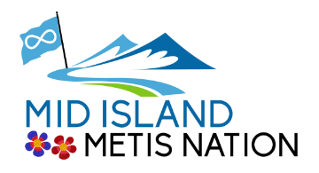

“Inspiring Métis Culture and Community.”

Mid Island Métis Nation Year in Review April 1, 2020 – March 31, 2021

Office Functions Daily and Weekly

- Regular posted hours Monday and Friday 10am to 12 noon. The two mornings posted allow for designated times for member applications, there is someone in attendance in the office other days of the week performing other duties during a variety of hours, call to confirm if someone is in (approximately 100 applications per year). Throughout 2020-2021 the office has had a staff person in 5 days a week.
- Currently have one full time and one part time staff, one full time volunteer and up to 4 part time volunteers as activity warrants within a variety of programs.
- Tracking the contacts to the office during the last year have identified that a third of the inquiries by phone, email and drop in are questions regarding education funding and other MNBC services.
- The communications to the office contain a host of inquiries, how to, who to go to if we have no services as Metis, cultural information questions, requests for programs and cultural classes, and education opportunities etc.
- Had a VIU practicum student working in the office January through to end of March. Much effort on her part to try and connect with the MIMN seniors by telephone just to do a check in.
- Camosun College practicum student during June.
- Youth summer student mid July - August

Events

- Aboriginal Graduation Recognition Ceremony in SD68, with a gift package delivered to each student, with a sash (donated by MNBC), medicine bundle MNBC Employment & Training info and Métis Pin. Metis student grad numbers 35 this year.
- Tsawalk Graduation Ceremonies SD84 presentation to the 14 Graduates of beaded medallions created by Joy Bremner
- National Indigenous Peoples Day June 21 was virtual. Posted numerous words from MIMN Board members, community members and a variety of cultural videos MIMN has produced along with various cultural posts.
- Remembrance Ceremony, a Metis Veteran, laid the MIMN wreath.
- The City of Nanaimo proclamation that the week of November 15-21 is Métis Awareness Week in the City, Flying of the Metis Flag at City of Nanaimo City Hall November 16th Louis Riel Day as well at Town Hall in Ladysmith, colouring pages shared across SD68 and various info pages for teachers
- Activities in the MIMN schools we partner with, Naisaika Kum Tuks and Tsawalk 1 & 2, a Metis cultural activity in each school, along with the Wiichihew Education supports in SD 68 and 84 and on the Vancouver Island University Campus.

- Activities during the last year

- Mamawapowuk (gathering) once a month (5) drive by pick up of a variety of food, culture, gardening, wellness handouts. For instance, saskatoon berry, sweetgrass plants, tomato and hanging strawberry plants; medicine bundles, Bannock mix, information pkgs; children’s books, simple craft kits, dental kits are examples of the items available on certain dates.
- Reconciliation Quilt 94 Calls to Action the format that each of the squares was constructed to represent. Our thanks to the Vancouver Exhibition for coordinating.
- Good Food Box weekly availability, Grocery supports along with various cultural hand outs
- Virtual Beading class led by Joy Bremner
- Women’s virtual sessions organized by the MNBC Region 1 Women’s Representative. Once a month a package to participants with various items included along with a book each month. There were women from around the island participating
- Métis Artist interviews published in the Mid Island Email Announcements

Programming

Kiikew
- Safe space workshops organization info enabling open conversations creating an understanding of the roots of international family and community violence
- Work with Island Health re COVID Vaccination rollout in Nanaimo and Duncan
- Guided virtual gatherings to share stories, histories and challenges
- Dealing with grief and regional leadership mental health sessions
- Self-led virtual course by Monique Gray Smith “The Ripple Effect of Resilience”
- Youth homeless supports through the NAC street program
- Direct phone connection with seniors and Elders to determine needs

Kishkayhta – Learn and Know
- Offered upgrading programs, Complete high school courses
- Get workplace certifications, Foodsafe, First Aid and other Short Term Certifications
- Marine Training Program
  - Restricted Operators Certificate – Maritime
  - Marine Basic First Aid
  - Small Vessel Operators Proficiency Training
  - Small Non-Pleasure Domestic Vessel- - Basic Safety

BC Arts
- Presenting Métis Author Spencer Sheehan-Kalina to do author readings to four independent Aboriginal schools in Central Vancouver Island region
- The creation and development of Cultural Art Kits that were packaged and distributed with options to connect virtually if wanting instruction re Kit projects.
- Upgrading of the office communications through increased capacity in the weekly email announcements
- Artistic and Production staff enabled resourcing of virtual options for programming going forward

Culture and Heritage City of Nanaimo
- Staffing of regular office hours has continued the supports to Métis applying for Métis Citizenship applications during the year, number actually increased during the year we believe as a result of COVID and the availability of supports available out of the MIMN office and MNBC
- Membership data base maintenance and expansion of the profile content of citizens
- Weekly announcements sharing the community activity information, education & employment opportunities and promoting the local service agency programming
- Social Media postings of programs and assists
- Management of the COVID-19 supports that MIMN received as additional funds from various funders

Red Cross Community Supports
- Meeting the unmet food related needs of vulnerable Metis community members.
- Increasing access to farm fresh healthy fruits and vegetables during the height of the pandemic, and increasing consumption of these foods among vulnerable community members.
- Helping community members who were financially stretched after the holidays and almost 12
consecutive months of pandemic related economic issues.
- Vulnerable community members have reported feeling grateful for the support provided through the programming during the pandemic. Many community members struggled with employment and access to food supplies. The hamper program bridged an economic gap created by COVID 19 among Métis Elders, children and families.

MNBC UPIP funding
- The programs and services which were contributed to by the UPIP funding include; bead, drum, moccasin, leather vest, dream catcher, and paint workshops. Outdoor Youth jigging performance video, outdoor women and girls gathering to discuss current issues and concerns.
- A number of celebrations throughout the year such as virtual National Indigenous Peoples Day, Orange Shirt Day, Women’s Day, Remembrance Day, Pink Shirt Day, Louis Riel Day Nanaimo Museum display for the month of November and Métis Awareness Week in Nanaimo.
- Elder driven outdoor give away in Ladysmith and Nanaimo of cultural foods (Bannock mix, bison and pemmican), health supports (tooth paste, brushes, sanitizer, masks).
- Services always are inclusive of referrals to various support agencies in Nanaimo, an ongoing updated information list compiled in the office.

ISPARC
- Kilometres walked took participants from Nanaimo over the mountains, across some foothills and prairies to Batoche and back. Congratulations folks a great interesting activity.
- Run/Walk event around Buttertubs Marsh well attended by members, created an excellent opportunity as ribbon skirt/shirts, and sashes on participants opened the conversation with others walking about the Métis.

- Wiichihew
- The support of students continued throughout the year even if different as a result of COVID, connection to Tsawalk students continued
- it varied as students doing much virtual learning, the SD did not allow the program staff into schools to meet with students but did have connection through teams on line meetings with education support workers

The efforts of the many volunteers and the staff in the office have been a major component of the programming, supports and handouts we were able to provide. It is with deep appreciation of their efforts during this time that MIMN acknowledges and thanks them for their contributions. Local agencies have also been instrumental in our office attempts to meet the needs of our members. Foodshare etc. local producers have added stability to our weekly supports including some interesting recipes on occasion.

Supporters/Partners

Nanaimo Art Centre SEIA
Child Development Centre Boys & Girls Club
Brechin Hill Community Association Nanaimo Community Gardens
Inter Tribal Health Community Living Association
MNBC Regional Governance Council Kumut Lelum
Nanaimo Youth Services Centre Vancouver Island University
City of Nanaimo Nanaimo Aboriginal Centre
Nanaimo Ladysmith Public School District Gold River Public School District
Literacy Nanaimo VIHA Aboriginal Health Métis Nation of British Columbia HMS Vancouver Island University Cowichan Valley Metis Nation Nanaimo Brain Injury Society Multi Cultural Society Nanaimo Citizen Advocacy Association Nanaimo Food Share First Nations Health Authority

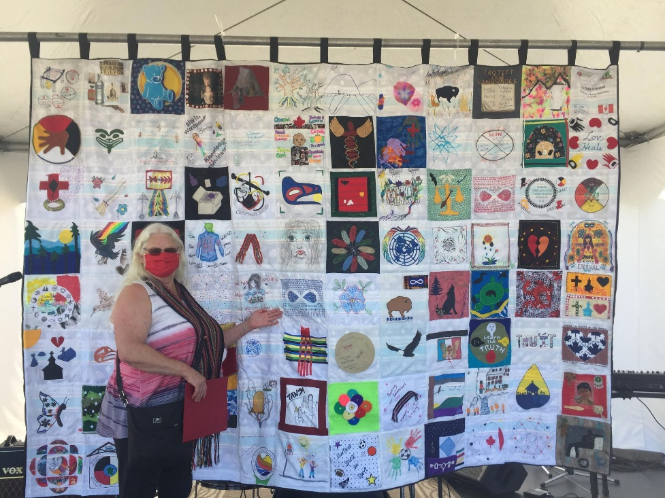

RECONCILIATION QUILT – IN PARTNERSHIP WITH
VANCOUVER ISLAND EXIBITION

