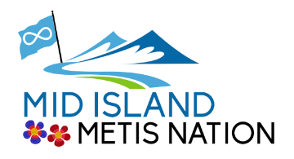

“Inspiring Métis Culture and Community.”

October 2021

Greetings

As we have made our way through this year during the pandemic everything has functioned differently than in previous years. The Mid Island Métis office has actually been busier than in normal years as funding from MNBC, the Red Cross and various other organizations for supports to families that have struggled during the various restriction levels has been incredible. This created undertakings that are outside of the usual programming/activities that we would be organizing.

On behalf of the Métis community thanks goes out to the funders and various agencies that enabled MIMN to support our members!

Throughout the 2020-2021 fiscal year serious attention was given to the regular email announcements, personal email & phone communication, a greeting card undertaking with seniors as well as face book posts from the office attempting to keep people informed of the various options for supports and virtual activities that were available.

Going into the 2021-2022 fiscal year we hope for somewhat of a return to more normal functioning as MIMN is in a good position to increase and provide a wide variety of programming which we have been looking forward to.

The Métis Nation of BC has found a significant amount of funding in comparison to the past, that will be coming directly to the Chartered Communities for supports, programing and capacity. This is definitely an indication that the Community Presidents are being heard at the many meetings we have been attending virtually. Much of this funding is not ongoing but for the current year, there is hope MNBC will be able to continue locating similar funding to take us forward on a regular basis.

Sincerely
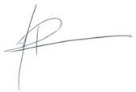

Joy Bremner
President Mid Island Métis Nation

